Main Files to Look At:

* **Index.html**
* **validateRegistration.js**
* **successfulRegistration.html**

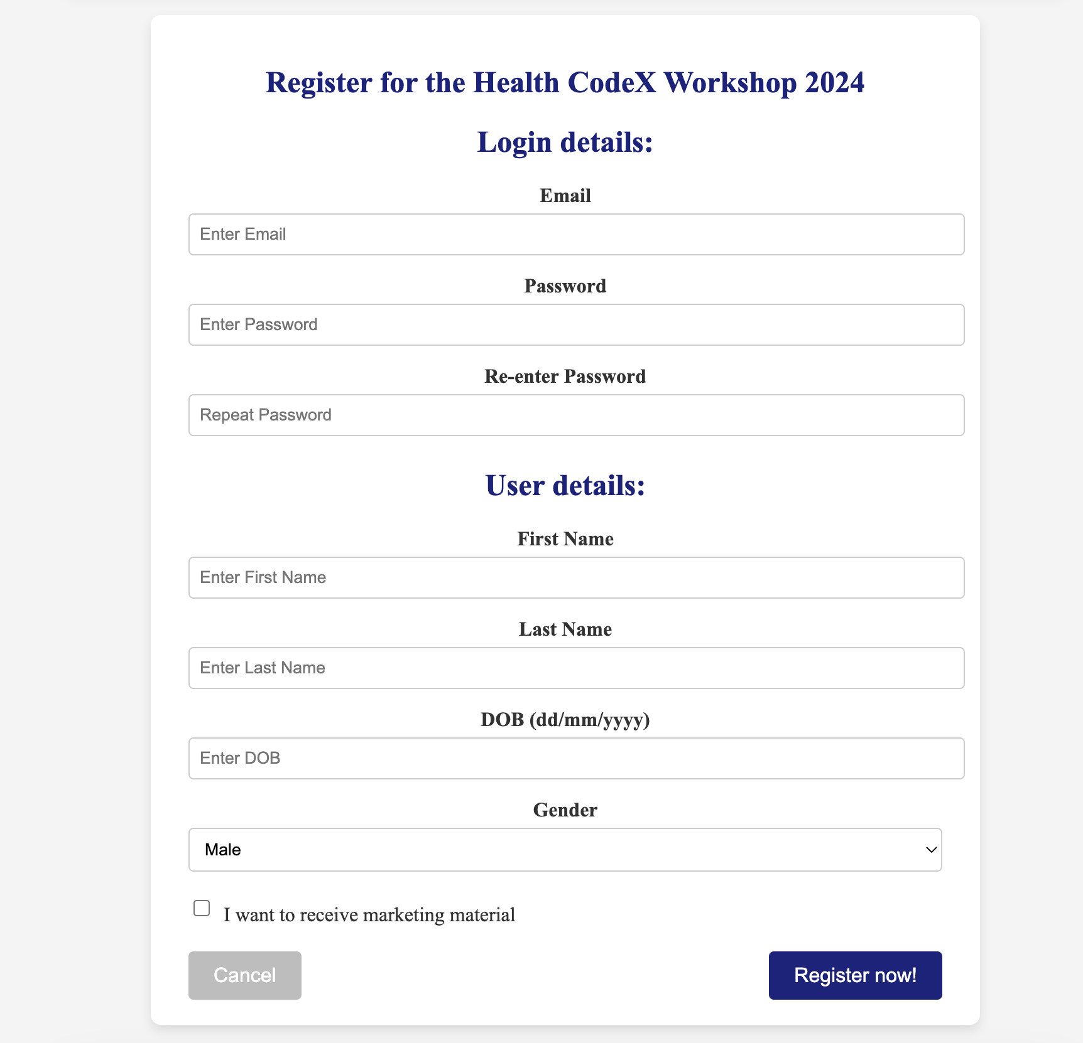

Figure 1: Registration Form at the Bottom of the Home Page (index.html)

Figure 2: Appropriate error messages for incorrect inputs

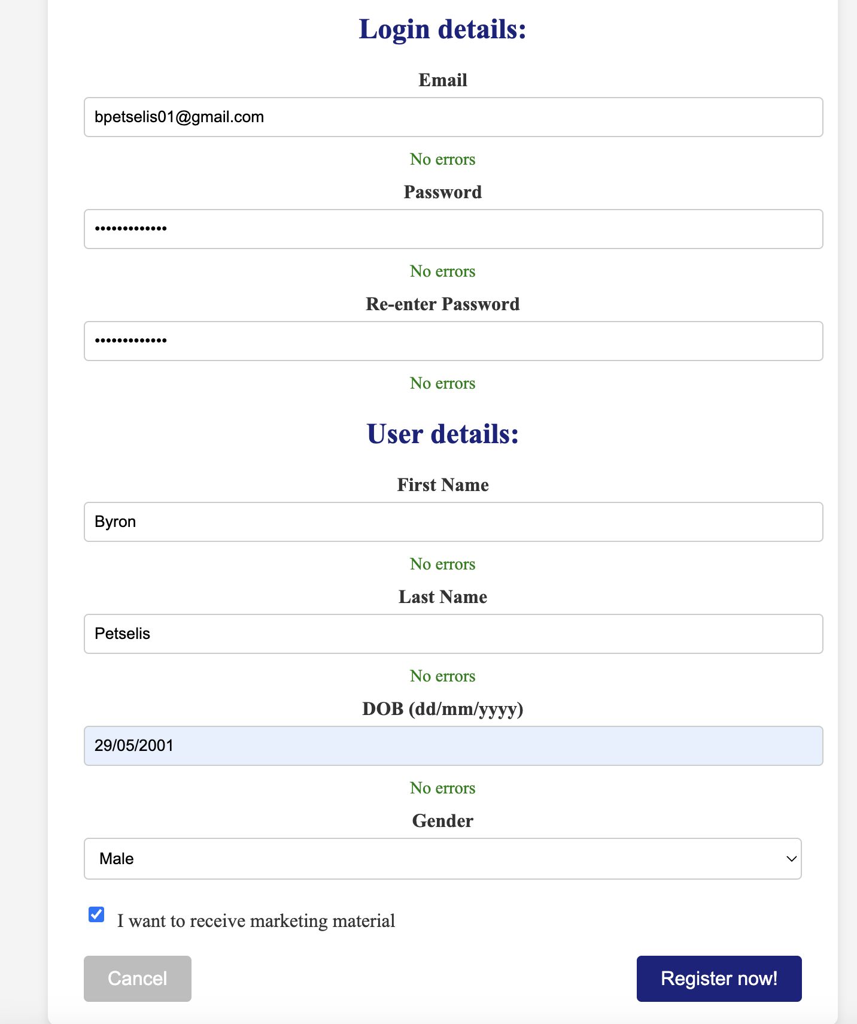

Figure 3: Appropriate success messages for correct inputs

Figure 4: Shows user that registration was successful

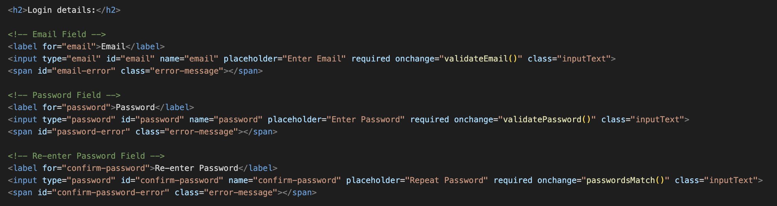

Figure 5: Initially register.html was a separate file, now moved into index.html

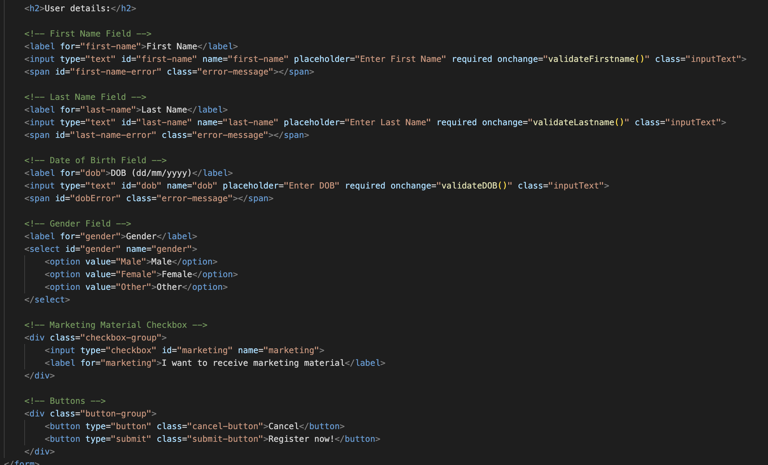

Figure 6: User Details

Figure 7: I used nested dictionaries to ensure that getting HTML inputs were simple in syntax and extracted common functions that I found in my other JS functions into two general validation functions to make my code more readable and cleaner

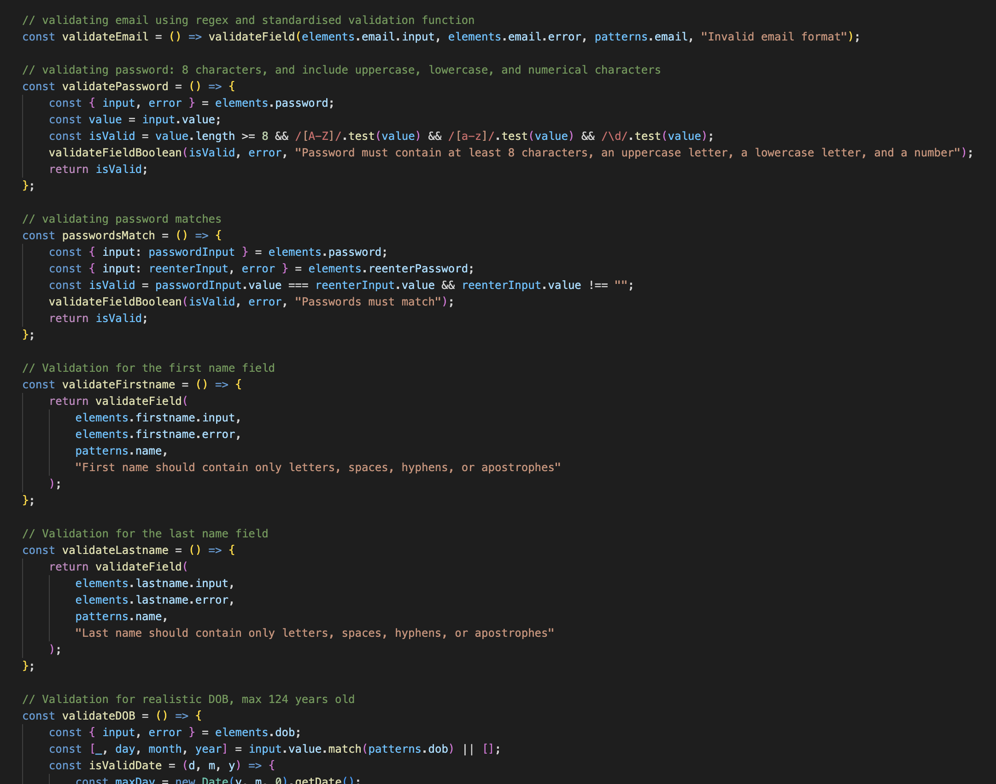

Figure 8: Some of the validation functions